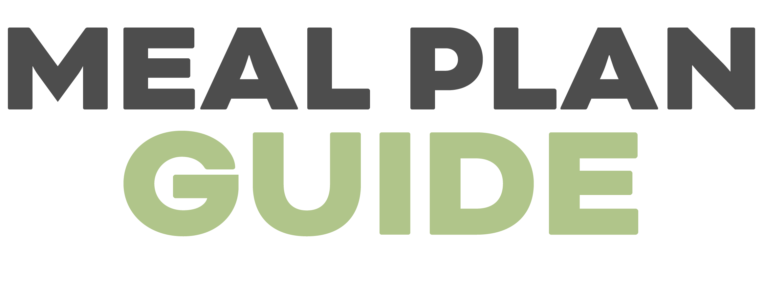

DINNER | MEAL | INGREDIENTS NEEDED
MON | Sheet pan dijon chicken + radishes
TUES | Caprese pesto salmon with cauliflower rice risotto
WEDS | Balsamic chicken berry salad
THURS | Breaded chicken with mushroom gravy and green beans
FRI | Ground beef taco meat bowls
SAT | Crispy baked eggplant and caesar salad
SUN | Pesto cauliflower rice stir fry

LUNCH | MEAL | INGREDIENTS NEEDED
MON | Keto chicken salad with butter lettuce
TUES | Leftover sheet pan dijon chicken
WEDS | Keto chicken salad with butter lettuce
THURS | Leftover sheet pan dijon chicken
FRI | Keto chicken salad with butter lettuce
SAT | Leftover ground beef taco meat bowls
SUN | Leftover ground beef taco meat bowls

BREAKFAST | MEAL | INGREDIENTS NEEDED
MON | Sunny side up eggs, spinach, bacon, avocado
TUES | Sunny side up eggs, spinach, bacon, avocado
WEDS | Sunny side up eggs, spinach, bacon, avocado
THURS | Sunny side up eggs, spinach, bacon, avocado
FRI | Sunny side up eggs, spinach, bacon, avocado
SAT | Sunny side up eggs, spinach, bacon, avocado
SUN | Sunny side up eggs, spinach, bacon, avocado
EXTRAS

VEGGIES
FRUIT
SNACKS
DRINKS
KID FOOD
OTHER

